ANNUAL EXHIBITION 2023

ONLINE ENTRY WORK FLOW PROCESS FOR CLUB CONTACT
- Entrant sends images to their Club Contact
  - This will be up to each Club Contact to define how they wish to receive images from their Club members
  - Entries should be accompanied with an individual entry form as this contains all the information the Club Contact requires
  - Remember – ALL print entries must also have a digital copy of the print.
- To access the system click on http://photoexhib.com/nempf/login.php
- The first screen displayed is the Welcome screen

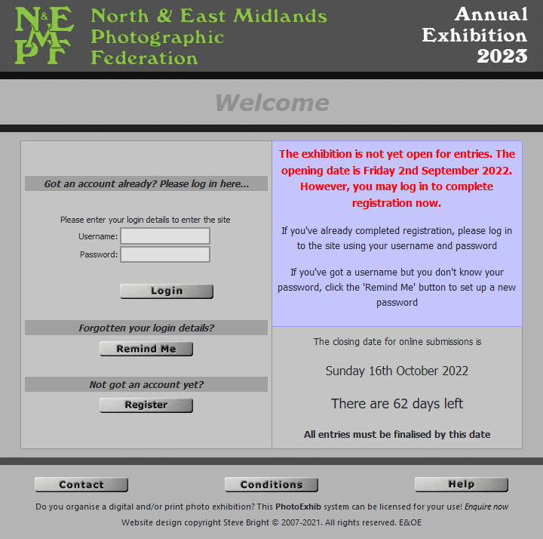

- EVERY entrant must be individually registered. Therefore ensure any Username and Password is deleted first and then press Register. Then follow the steps below.

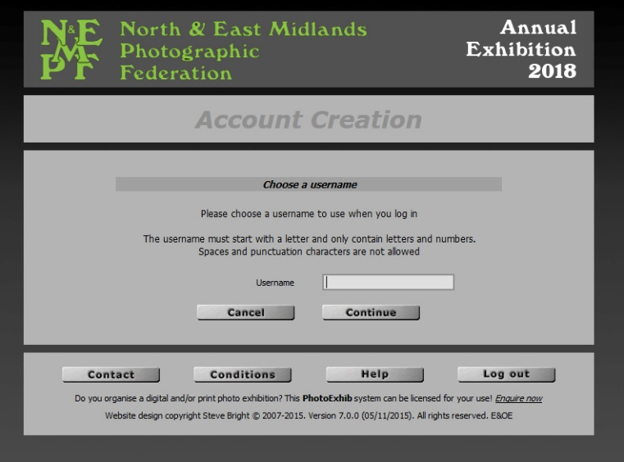

- Select a User name and press continue.

- The Continue Account Creation screen will now be displayed where you must enter a password and email address.

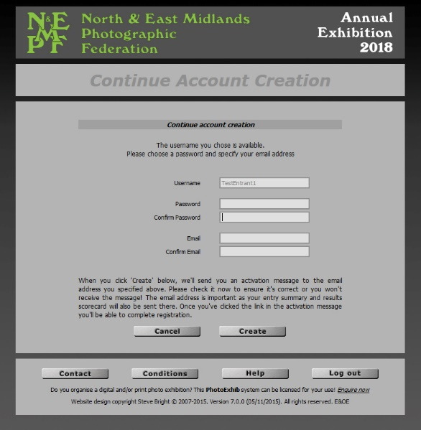

The email address should be the valid email address of the Club Contact as all communication and Club results will be sent to this email address.

- Once the individual details have been entered the following screen will be displayed and an activation email sent to the Club Contact’s email address provided that the Club Contact remembered to use their email address for each entrant.

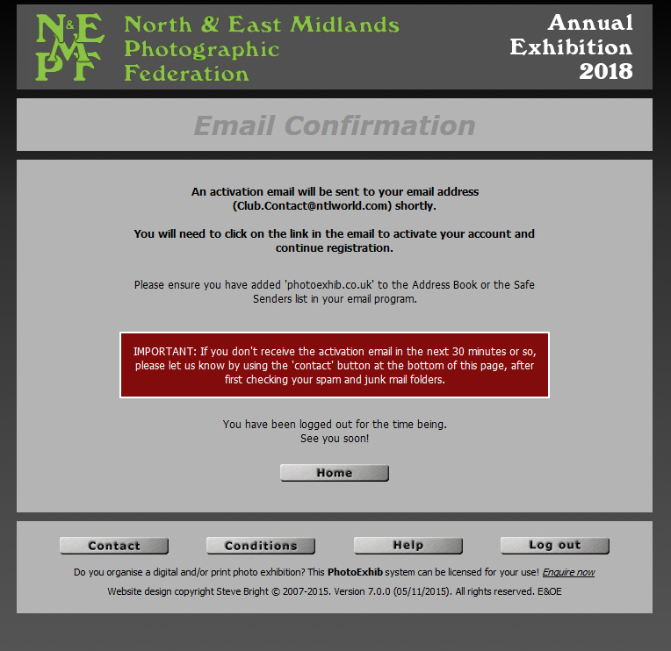

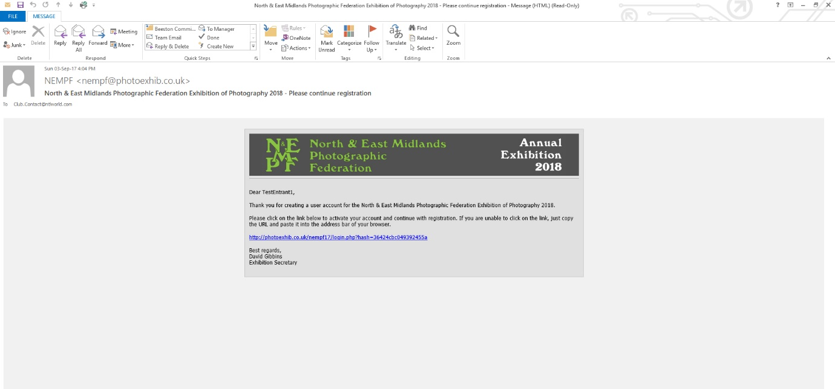

- The next screen to be displayed is the Account Registration screen

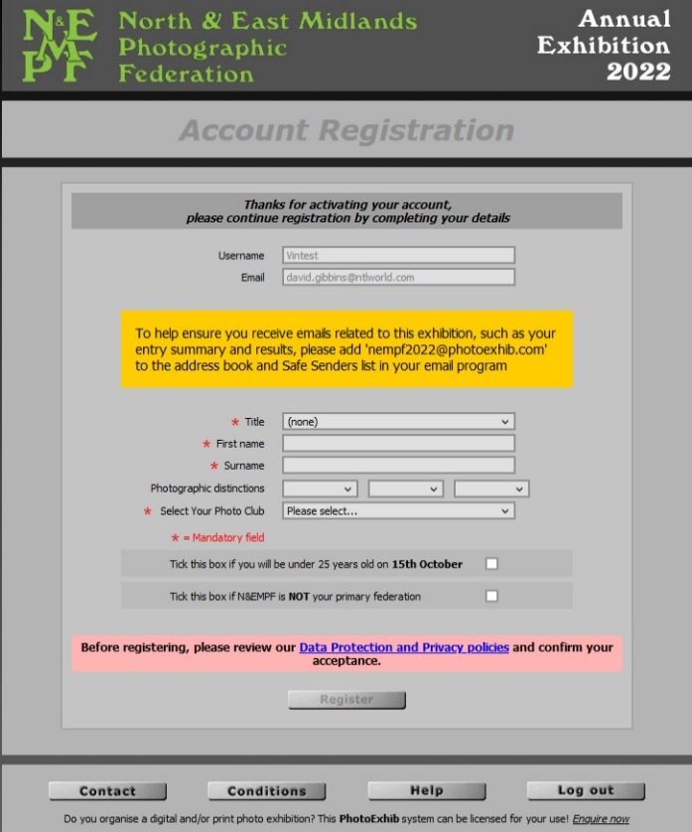

This must be completed for each person. For each different entrant please put the correct name and photographic honours in and ensure you select the correct club for the entrant.

There is a new indicator for 2023 – “Tick this box if N&EMPF is NOT your primary federation”. The default for entering the N&EMPF Exhibition is that accepted images into the Exhibition can be used to represent N&EMPF in inter-Federation competitions. It is acknowledged that some members are also members of clubs in another Federation and would prefer to enter images for that Federation. In such cases tick this box.

- This process will be followed for every entrant and it is critical that the Club Contact uses their own email address for every one of their entrants.

- Once the account has been activated it is then possible to upload the images.

- Once all images have been uploaded for that specific entrant, including digital files of any prints, the Club Contact must then finalise the entry.

- The Club Contact can amend the details up to the closing date but MUST remember to finalise the entry again otherwise it will not be uploaded.

- The Club Contact receives an entry summary email which he/she can forward to the entrant if desired (handled manually by the Club Contact)

Please be aware:
- The Club Contact MUST NOT use any other email address, except their own, when uploading club members images, otherwise they are out of the loop for that entrant and will not be informed of results.
- If the Club Contact registers using their own name instead of the entrant's name then it means that the images for that entrant are all attributed to the wrong person i.e. the Club Contact.

Individual entries must be completed by Sunday 16th October. On Monday 17th October the system will be set to allow the Club Contact to log in to nominate entries for the three trophy panels from all of the images that have been uploaded for that club. This must be completed by midnight on Friday 21st October.
When the results are published, a scorecard email for each entrant will be sent to the Club Contact. The Club Contact should then forward the scorecard to the individual entrant as soon as possible.

ANNUAL EXHIBITION 2023

N&EMPF CLUB ENTRY PROCESS
Clubs can nominate panels to enter the Hiscox, Chesterfield and Derwent Trophies.
Trophy | Description | Images from these entry classes
Hiscox | Monochrome Print | Monochrome Print
Chesterfield | Colour Print | Colour Print, Nature Print
Derwent | PDI | Monochrome PDI, Colour PDI, Nature PDI

Each panel must be four photographs from four different photographers and each panel must show a variety of subject matter.
A panel may include a landscape, portrait, action and still life for example, but not two different sports pictures or a portrait and re-enactment portrait etc.
Each panel will be shortlisted based upon the aggregate scores of each individual image
The selected short listed panels will then be reviewed for variety of subject matter
The Club Trophy winner will therefore be based upon the aggregate individual score of each image and variety of subject matter
The Club Contact has the responsibility for entering the panels through the online entry system. This process will be undertaken after the individual closing date 16th October 2022 and must be completed by Friday 21st October 2022.
A special login account has been set up for you solely for this purpose. It can only be used for nominating images for the three Trophy awards from images that have already been entered.
Use these special login credentials you have been sent to log in at the usual Exhibition entry website: http://photoexhib.com/nempf/login.php
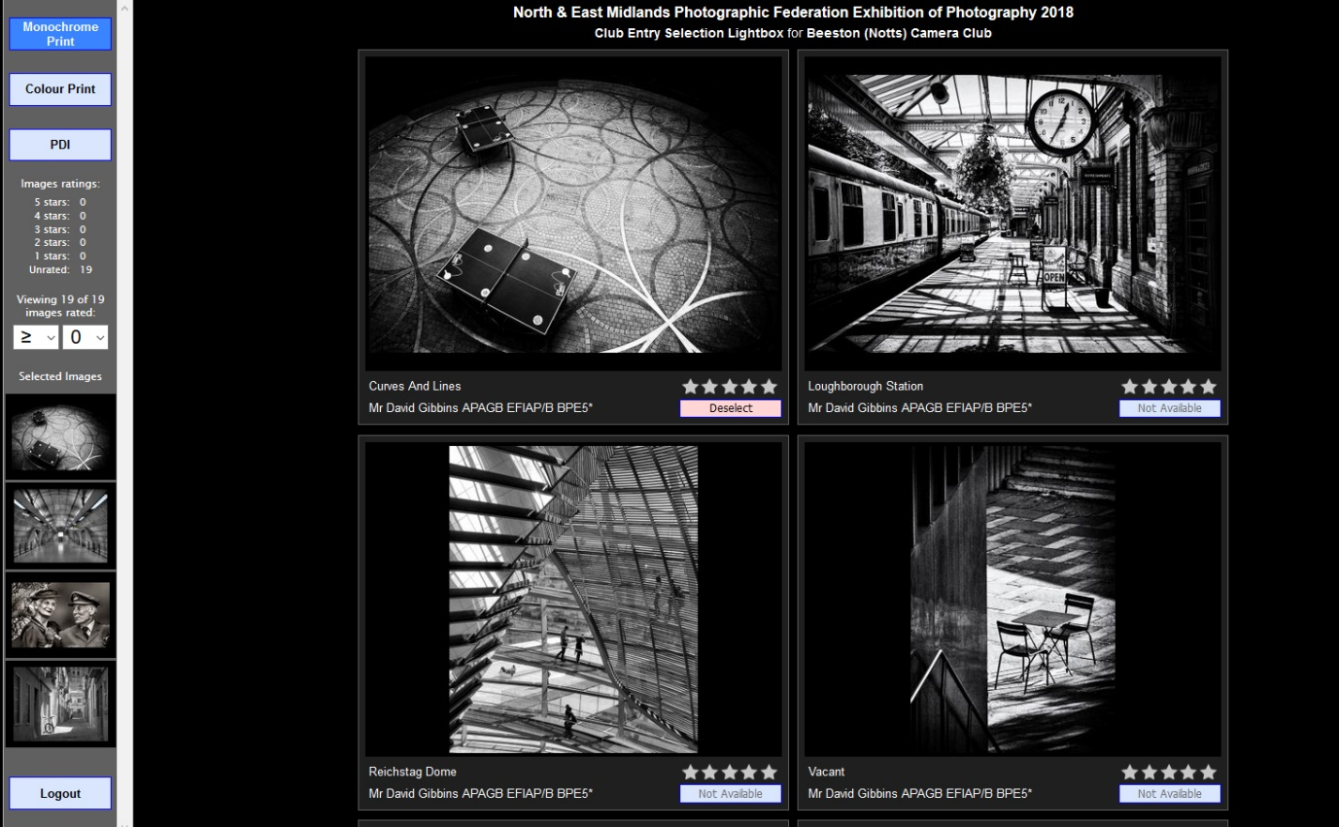
The process is as follows:
- When you log in, a message will appear asking you to click on a Club Award category. When you click 'Ok' you will be taken to a 'lightbox' screen which will initially be empty.
- There are three buttons to choose from at the top of the left sidebar, corresponding to the three Trophy Awards: 'Monochrome', 'Colour' and 'PDI'.
- When one of these is clicked, the complete set of images that have been uploaded for your club which qualify for your selected Trophy Award will be displayed.
- Each image has a 'Select' button. You will be able to select four images with these buttons, for each of the three Trophy Awards.
- If you change your mind, you can deselect an image and select a different one.
- You won't be able to select more than four images, nor select an image more than once.
- When you click the 'Select' button for an image, a small thumbnail of that image will appear on the left sidebar so you can see at a glance which images you've selected.
- If you have a very large number of images to choose from you may like to use the provided star rating system to help whittle down the images on display to a more manageable level. A rating may be given to an image (from 0 to 5 stars), by clicking on the stars, in much the same way as you would rate a product on Amazon or similar websites.
- The numbers of images with each star rating is shown in the left sidebar. There is also a filtering mechanism which you can use to, for example, show only those images which you've rated 4 stars or above.
- In particular, if the left-hand dropdown is set to '=' and you set the right-hand dropdown to 'Sel', you will see the images that you have clicked the 'Select' button for.
- The star rating of images has been provided entirely for your benefit to help you choose the images you wish to nominate. It is not necessary to rate any images, and any star-rating given will have absolutely no bearing on results or judging.
- Once you've made your selection of images, click the 'Logout' button on the left side bar.
- If you can't see the 'Logout' button, it could be that it is off the bottom of the page: try scrolling the left side bar.
- Selections are recorded in the Exhibition database immediately - it doesn't matter if you simply close the web page without logging out.
- You can return to this web page by logging in with these credentials as many times as you like, changing or viewing your selection as you wish. Your final selection of images nominated for the Club Trophy Awards will be taken at the entry closing date.
- You will not be able to enter images with this login – it exists solely for the purpose of nominating images for the Club Trophy awards.

ADDITIONAL INFORMATION REQUEST
To assist with the production of the CD’s of accepted PDI’s and accepted Prints the Federation would be very grateful if the Club Contacts can obtain email addresses of all entrants, where given. This will enable Ashley Franklin, who assembles the exhibition audio-visual to obtain information about the image thereby making the audio visual more informative.

