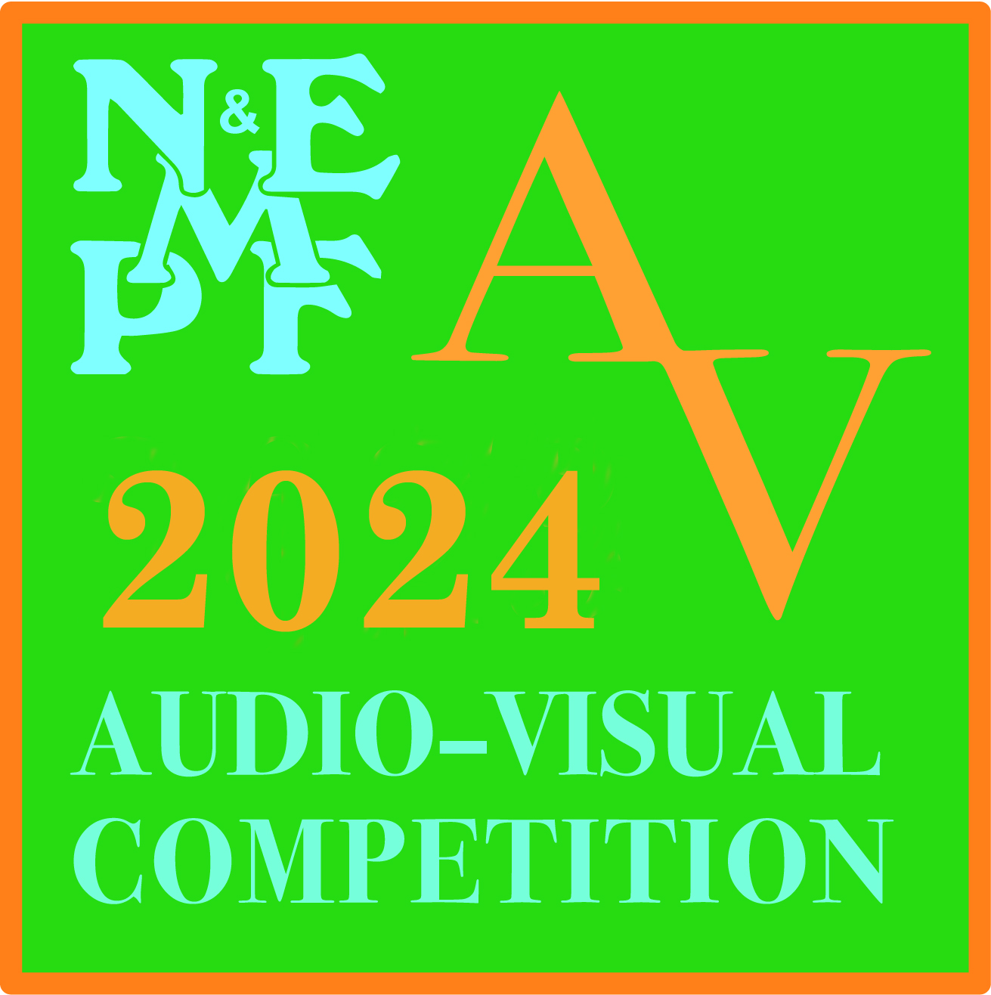
North & East Midlands Photographic Federation

6th Audio Visual Competition
2024 ENTRY FORM

To be completed and returned with ENTRY FEES to:-
David Gibbins ARPS APAGB EFIAP/b BPE5 COAGB A/V 18, Gunnersbury Way, Nuthall, Nottingham NG16 1QD

To arrive no later than 5th March 2024

PLEASE USE BLOCK CAPITAL LETTERS

Entrant MCPS Licence No
Club / Society

Email

Address

Postcode

Telephone No Emergency No

Collaborator

ENTRIES
Sequence | Title | Narrative | MSP | Sequence  Duration
Sequence 1
Sequence 2

Entries can either be one in each section or two in one section
Entries in the Narrative section must NOT exceed 8 minutes
Entries in the MSP section must NOT exceed 6 minutes

Author(s) of text __________ Spoken by __________

Number of Sequences @ £5.00 each

TOTAL ENTRY FEE £

Please make a cheque payable to: ‘North & East Midlands Photographic Federation’

Or payment can be sent electronically to:
Name: North and East Midlands Photographic Federation
Sort Code: 601323 Account Code: 97543578
Reference: must be name of entrant
Please indicate if paying by Bank Transfer Yes/No

